PRODUCT DATA SHEET

G

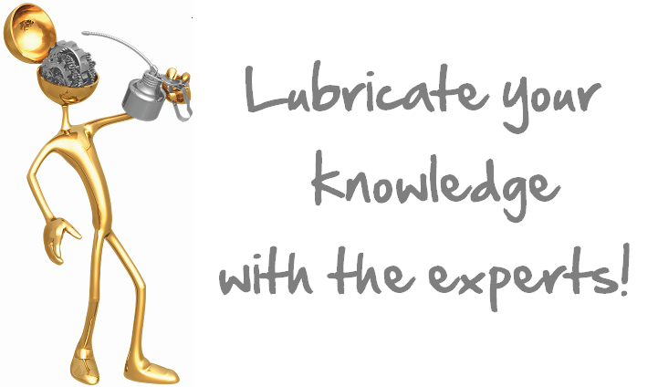

SL-OG
OPEN GEAR COMPOUND

PRODUCT DESCRIPTION

Sentinel SL-OG is a unique synthetic metallic compound designed for general purpose open gear lubrication. It has a high tack content that prevents it from slinging out even at high RPM’s. It is specifically formulated to stay on exposed and open gears, resisting extreme temperatures as well as extreme pressures from close moving parts. SL-OG has a thermal range from -28°C (-20°F) to 232°C (450°F) and an E.P. rating in excess of 150,000 psi.

Sentinel SL-OG has metallic particles incorporated into its synthetic carrier, making it bronze in color and giving it greater plating action.
TYPICAL CHARACTERISTICS

Under pressure, these solid lubricants are carried into the gear faces and moving surfaces, all score marks, pits and grooves or other facial imperfections are filled in and a uniform low friction coating forms. Shock and noise are reduced, uneven wear is prevented and it can even be applied while equipment is running.

Unlike petroleum based open gear lubes, SL-OG is not susceptible to water and is not affected by heat, cold, or extreme pressures. It will not harden in cold weather, or melt out in warm weather.

NLGI Grade 1 ASTM D-1092
Worked Penetration 310-340 ASTM D- 217
Dropping Point None ASTM D-2265
Oxidation Stability
Psi drop @ 100 hrs -1 ASTM D- 942
Rust Preventative 1a ASTM D-1743
No Stain
Water Washout 0.6 ASTM D-1264
Extreme Pressure 45+ (100) ASTM D-2509
Timken OK Load Kg (Lb)
Four Ball Wear .6 mm ASTM D-2266
Solids Copper Bronze
USDA Rating H-2
Appearance Gold Metallic Tacky

PIN # 03057
TO ORDER or FOR ADDITIONAL INFORMATION

