PRODUCT DATA SHEET

G



SCO REF Series

REFRIGERATION OIL

PRODUCT DESCRIPTION

Sentinel’s SCO-REF Oil Series are a family of fully synthetic industrial lubricants developed specifically for refrigeration compressors. They are especially formulated synthesized hydrocarbon lubricants for severe service under conditions that are beyond the capabilities of conventional mineral oils. In addition, they improve the performance and efficiency of standard refrigeration systems compared to conventional mineral oils.

Sentinel SCO-REF have very low pour points, zero wax content, a high natural viscosity index and high thermal stability. They exhibit greater chemical stability in the presence of refrigerants and other system components, and have a low volatility. Their low solubility makes them suitable for systems using refrigerants such as R12, R22, R114 and ammonia.

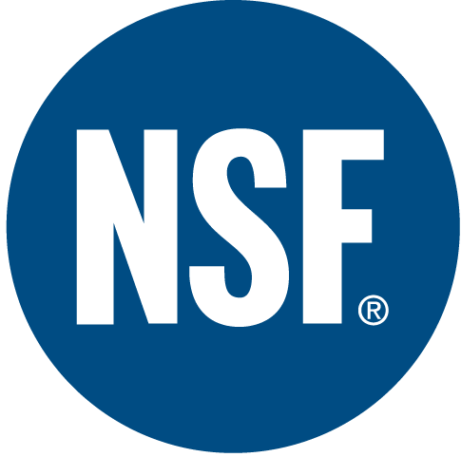

TYPICAL CHARACTERISTICS

Improved wear protection at high temperatures
No deposit formation in low temperature systems
Fewer discharge valve deposits
Improved compressor efficiency

TO ORDER or FOR ADDITIONAL INFORMATION

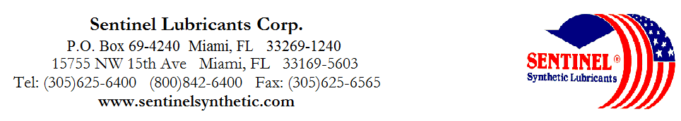

SCO REF Series

REFRIGERATION OIL

TYPICAL CHARACTERISTICS

SCO-REF 32 SCO-REF 46 SCO-REF 68 SCO-REF 100 SCO-REF 150 SCO-REF 220 ASTM METHOD

ISO Viscosity Grade 32 46 68 100 150 220 D-2422
SAE Viscosity Grade 10 10W20 20 30 40 50
Viscosity cSt @ 100°C 5 7.9 10 14 20 25 D-445
@ 40°C 29 43.9 62 99 160 220 D-445
Viscosity Index 132 145 148 144 145 143 D-2270
Pour Point °C (°F) -54(-65) -50(-58) -48(-55) -43(-45) -40(-40) -40(-40) D-97
Flash Point °C (°F) 218(425) 218(425) 222(431) 229(445) 248(478) 250(482) D-92

Foam Sequence I, II, III ------------------------------------------------------------------ Nil --------------------------------------------------------------- D-892
Demulsibility, ------------------------------------------------------------- 40/40/0(15) -------------------------------------------------------- D-1401
54.4°C (130°F)
Four Ball Wear, mm 40kg, ------------------------------------------------------------------ 0.5 --------------------------------------------------------------- D-2266
1200 rpm, 75°C (1hr)

Copper Corrosion ------------------------------------------------------------------ 1a --------------------------------------------------------------- D-130
121°C(250°F), 3 hrs

Rust Test ----------------------------------------------------------------- Pass -------------------------------------------------------------- D-665A&B

Color Observed --------------------------------------------------------------- Clear -------------------------------------------------------------
Food Grade Status ------------------------------------------------------------------ H1 -------------------------------------------------------------- NSF

NSF Registration 137650 137651 137652 137653 137654 --------

PIN# 11301 11310 11305 11307 11312 11315

