PRODUCT DATA SHEET

G



SH Series
ANTI-LEAK, ANTI-WEAR HYDRAULIC FLUID

PRODUCT DESCRIPTION

Sentinel’s SH Line of Synthetic Hydraulic fluids are anti-wear, anti-leak fluids specifically engineered to meet the requirements of modern high performance pumps and industrial and mobile hydraulic systems. They are blended from premium quality base stocks with a superior combination of oxidation inhibitors to prevent sludging and deposit formation; a high level of E.P. additives to meet the wear protection requirements of all pump manufacturers; foam suppressants to eliminate foaming, and dyed red for ease of identification; and finally a new Polymer additive to arrest leakage.

PRODUCT ADVANTAGES

The SH Line of Hydraulic fluid offers superior protection against corrosion, rubber swelling and foaming and exhibits excellent water demulsibility characteristics. These are the
qualities that are required to assure efficient, trouble-free operation of the new high-pressure hydraulic systems. The use of SH Hydraulic Fluids minimizes wear and mechanical problems within any hydraulic system, and reduces all leakage to an absolute minimum.

For applications with special requirements such as a wide range of operating temperatures, very low start-up temperature, or extremely high operating pressures, we recommend Sentinel Hydraulic Fluids.

Extended drain intervals
Superior demulsibility
Non-foaming
Seal compatible
Reduced downtime
Reduced equipment operational problems
Reduced maintenance costs
Improved Safety
Reduce oil leakage
Eliminates seasonal oil change
Exceptional high temperature stability and performance durability
Improved Oxidation Stability
Energy Conservation
Cooler running
Provide outstanding high temperature and oxidative stability
Superior resistance to sludge formulation
Outstanding protection against wear
Resist rust and corrosion
TO ORDER or FOR ADDITIONAL INFORMATION

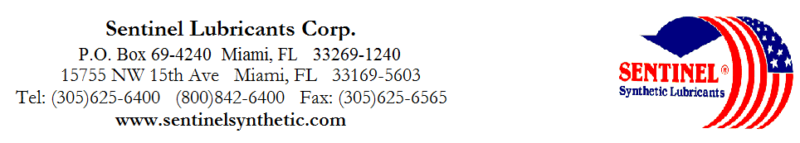

SH Series
ANTI-LEAK, ANTI-WEAR
HYDRAULIC FLUID

TYPICAL CHARACTERISTICS

SH 5 SH 10 SH 10/20 SH 20 SH 30

ISO Viscosity Grade 22 32 46 68 100 ASTM D-2422

SAE Viscosity Grade 5 10 10W20 20 30 SAE J - 300

Viscosity cSt @ 100°C 3.8 6 8.5 10.5 13 ASTM D- 445
@ 40°C 22 32 46 68 100 ASTM D- 445

Pour Point °C (°F) -40(-40) -40(-40) -37(-35) -34(-30) -32(-25) ASTM D- 97

Flash Point °C (°F) 210(410) 220(428) 226(438) 228(440) 230(446) ASTM D- 92

Fire point °C (°F) 232(449) 232(449) 250(482) 252(485) 250(489) ASTM D- 92

Foam Sequence I, II, III -------------------------------------------Nil---------------------------------------------- ASTM D- 892

Demulsibility 54.4°C(130°F) -----------------------------------------40/40/0(15)-------------------------------------- ASTM D-1401

Copper Corrosion 121°C(250°F), 3 hrs -----------------------------------------1a------------------------------------- ASTM D- 130

Rust Test --------------------------------------------Pass-------------------------------------------- ASTM D-665A&B

USDA Rating ---------------------------------------------H-2-------------------------------------------

Color Observed ---------------------------------------------Red--------------------------------------------

Physical Properties -------------------------------------------Non-Leak---------------------------------------
PIN# 10010 10020 10100 10040 10060
TO ORDER or FOR ADDITIONAL INFORMATION

