PRODUCT DATA SHEET

G

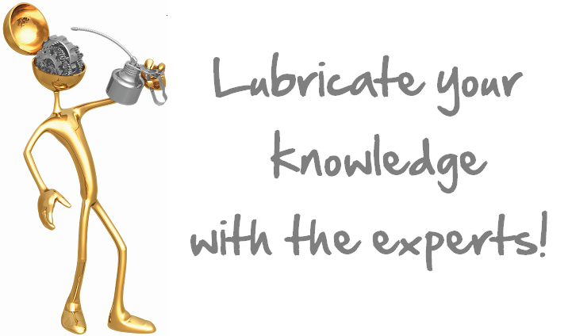

S-ATF
AUTOMATIC
TRANSMISSION FLUID

PRODUCT DESCRIPTION

Sentinel’s S-ATF is a multi-purpose synthetic DEXRON® III / MERCON® universal multi-functional fluid for automatic and power lift transmissions for all industrial and mobile systems.

S-ATF keeps transmissions operating cooler and smoother, reduces drag for improved fuel economy and increases service life many times over petroleum fluids.

S-ATF enhances performance in severe and cold weather service. Its synthetic composition and low temperature fluidity offer superior wear resistance, as well as torque converter and equipment protection in cold starting situations.

Dexron®III is a registered trade name of General Motors Corporation.

Mercon® is a registered trade name of Ford Motor Company.

TYPICAL CHARACTERISTICS

ISO Viscosity Grade 32 ASTM D- 2422

Viscosity cSt @ 100°C 7.1 ASTM D- 445
@ 40°C 30.8 ASTM D- 445

Viscosity Index 196 ASTM D- 2270

Pour Point °C (°F) -50(-46) ASTM D- 97

Flash Point °C (°F) 220(428) ASTM D- 92

Fire point °C (°F) 242(468) ASTM D- 92
Foam Sequence I, II, III Pass ASTM D- 892
Demulsibility 82°C 40/40/0 (15) ASTM D- 1401

Color Observed Red

PIN # 08170
TO ORDER or FOR ADDITIONAL INFORMATION

