PRODUCT DATA SHEET

G

S-WAY OIL

Series
SYNTHETIC WAY OIL


PRODUCT DESCRIPTION

Sentinel® line of Way Oils are blended from high quality, synthetically treated base oils, a superior combination of extreme pressure, anti-wear, rust and oxidation inhibitors. In addition these oils are fortified with oiliness and special stringiness additives to impart tackiness and adhesiveness.

Sentinel® Way Oils adheres strongly to sliding metal surfaces and provide a tenacious lubricant. The tackiness combined with exceptional lubricity offers ideal lubrication for vertical as well as horizontal ways.

The low coefficient of friction overcomes the stick-slip motion associated with slow moving machine parts even after standing overnight. They are highly effective in controlling wear and protecting against galling.

Typical applications include sliding ways of machines including lathes, planers, shapers, drilling and tapping machines, grinders, boring machines, jig borers, milling machines and other applications requiring an adhesive, non-drip characteristic lubricant, such as enclosed gears and all types of industrial plain and anti-friction bearings.

Application methods are an oil can, oil cup, reservoir, splash, or by automatic dispensing equipment.

TO ORDER or FOR ADDITIONAL INFORMATION

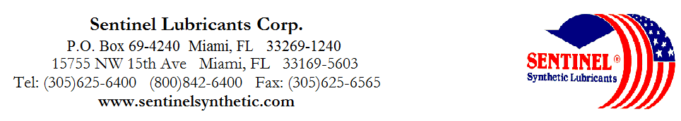

S-WAY OIL

Series
SYNTHETIC WAY OIL

TYPICAL CHARACTERISTICS

10 20 30 40 50 ASTM METHOD

ISO Viscosity Grade 32 68 100 150 220 D-2422

AGMA Lubricant Number --- 2EP 3EP 4EP 5EP

Viscosity cSt @ 100°C 6 10 14 18 23 D-88
@ 40°C 32 68 100 150 220 D-88
Viscosity Index 136 131 142 133 129 D-2270

Pour Point °C (°F) -40 (-40) -30 (-35) -35 (-30) -32 (-25) -29 (-20) D-97

Flash Point °C (°F) 200 (390) 205(400) 220 (428) 224 (435) 230 (446) D-92

Foam Sequence I, II, III -----------------------------------------------------NIL------------------------------------------------- D-892
Demulsibility, 54°C (130˚F) -------------------------------------------------40/40/0(30) -------------------------------------------- D-1401
Four Ball Test Wear, mm 40 kg, 1200 rpm
75˚C (1 hr) ---------------------------------------------------.5mm-------------------------------------------------- D-2266

Copper Corrosion 121°C(250°F), 3 hrs ----------------------------------------------------1a---------------------------------------------------- D-130
Rust Test ----------------------------------------------------Pass-------------------------------------------------- D-665AB

Timken OK Load kg/ (lb) 36+ (80) 36+ (80) 36+ (80) 45+ (100) 45+ (100) D-2509

Conradson Carbon 0.05 0.05 0.05 0.06 0.08 D-189
Appearance ----------------------------------------------Light Green------------------------------------------------ D-1500
PIN# 12250 12253 12255 12257 12260
TO ORDER or FOR ADDITIONAL INFORMATION

