PRODUCT DATA SHEET

G


S-NT CO Series
NON-TOXIC
COMPRESSOR FLUID
PRODUCT DESCRIPTION

The increased use of air compressors, not only in industrial plants in general but also in food-processing plants, has created a need for the development of new extended-life lubricants, including those meeting FDA and NSF requirements for incidental food contact.

This led to the development of Sentinel’s® S-NT-CO Series, a new synthetic compressor lubricant/coolant developed from polyalphaolefin (PAO) based fluids.

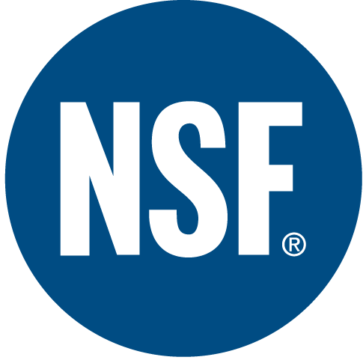

TYPICAL CHARACTERISTICS

Tests demonstrated that Sentinel’s® S-NT-CO Series synthetic fluid provided several advantages including good compatibility with the components in standard compressor systems and low foaming properties. It was also found to have excellent water separation and low water absorption as compared to diester fluids.

S-NT-CO Series meets all the FDA requirements for qualification as a white mineral oil (FDA Regulation 21 CFR 172.878) and means that the fluid maybe used in lubricants for incidental contact as a candidate for NSF rating H-1 for incidental food contact in meat and poultry plants. The additives used in formulating S-NT-CO also meet all the under Regulation 21 CFR 178.3570.

S-NT-CO10 S-NT-CO10/20 S-NT-CO20 S-NT-CO30 S-NT-CO40
ISO Viscosity Grade 32 46 68 100 150 ASTM D-1092
SAE Viscosity Number 10 10W20 20 30 40 SAE J- 300
Viscosity cSt @100°C 6 8 10 14 18 ASTM D- 445
@ 40°C 32 46 68 95 145
Viscosity Index 135 146 136 151 155 ASTM D-2270
Pour Point °C (°F) -60 (-76) -54 (-65) -51 (-60) -51(-60) -51(-60) ASTM D- 97
Flash Point °C (°F) 240 (464) 243 (470) 250 (482) 266 (510) 270(518) ASTM D- 92
Foam Sequence I, II, III ---------------------------------------- Nil -------------------------------------- ASTM D- 892
Four Ball Wear, mm
41 kg, 1200 rpm, 75°C (1 hr) ---------------------------------------- 0.5 --------------------------------------- ASTM D-2266
Demulsibility 54.4°C (130°F) ------------------------------------ 40/40/0(15) ----------------------------------
Copper Corrosion 121°C (250°F) ----------------------------------------- 1a ----------------------------------------- ASTM D- 130
Conradson Carbon Residue % ---------------------------------------- 0.02 --------------------------------------- ASTM D- 189
Auto ignition Temperature °C (°F) ------------------------------------- 400 (750) ------------------------------------ ASTM D-2155
Oxidation Test, hrs 4000+ 4000+ 4000+ 8000+ 8000+ ASTM D- 943
Food Grade Status ---------------------------------------- H-1 ----------------------------------------- NSF
NSF Registration 137207 137208 137209 137210 137211

PIN# 14500 14503 14505 14510 14515
TO ORDER or FOR ADDITIONAL INFORMATION

