PRODUCT DATA SHEET
G



S-NT-GO Series
FOOD GRADE GEAR OIL

PRODUCT DESCRIPTION

Sentinel’s Non-Toxic Gear Oil Series are specially compounded non-toxic, water white, tasteless, odorless, blend of USP fluid treated with synthetic compounds to produce a multi-purpose gear lubricant formulated to provide superior film strength and extreme pressure properties. They are anti-wear, anti-leak, anti-foam gear oils. They can be used in all types of enclosed gear mechanisms.

Non-Toxic Gear Oil Series is fortified with a special food grade polymer, to impart tackiness and adhesiveness, which adheres strongly to assure a tenacious lubricant film.

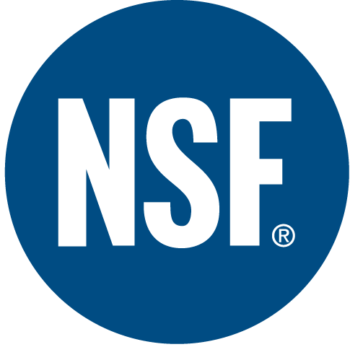

The Non-Newtonian behavior of these lubricants have shown greater reduction in friction and wear due to maintaining greater film thickness on gear teeth, thereby reducing amperage consumption, as well as reducing frictional heat.

Non-Toxic Gear Oil Series meets all the FDA requirements for qualification as a white mineral oil (FDA Regulation 21 CFR 172.878) and means that the fluid maybe used in lubricants for incidental contact with food as specified in 21 CFR 178.3570. This regulation qualifies lubricants as a candidate for NSF rating H-1 for incidental food contact in meat and poultry plants. The additives used in formulating Non-Toxic Gear Oil Series also meet all the requirements under Regulation 21CFR 178.3570.

TO ORDER or FOR ADDITIONAL INFORMATION

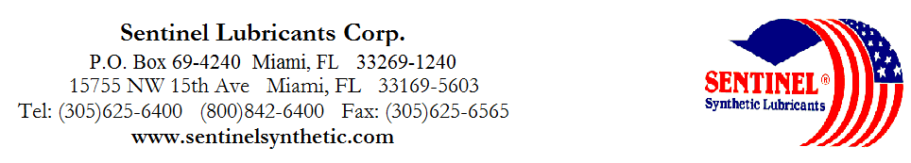

S-NT-GO Series
FOOD GRADE GEAR OIL

TYPICAL CHARACTERISTICS

NON TOXIC GEAR OIL 75 80 75/80 75/90 80/90 90 90/140 140 250 ASTM METHOD

ISO Viscosity Grade 32 46 68 100 150 220 320 460 680 D- 2422

AGMA Lubricant Number 1EP 2EP 3EP 4EP 5EP 6EP 7EP 8EP

Viscosity cSt @ 100°C 6 8 10 14 18 23 29 37 48 D- 445
@ 40°C 32 46 68 100 150 220 320 460 680 D- 445
Viscosity Index 133 146 131 142 124 124 124 124 124 D- 2270

Pour Point °C (°F) -48(-55) -46(-50) -43(-45) -40(-40) -37(-35) -34(-30) -32(-25) -29(-20) -26(-15) D- 97

Flash Point °C (°F) 231(448) 233(451) 236(457) 249(480) 250(482) 254(490) 270(518) 280(535) 280(535) D- 92

Foam Sequence I, II, III --------------------------------------------------------------------------- Pass ----------------------------------------------------------------------------- D- 892
Demulsibility 82°C ----------------------------------------------------------------------- 40/40/0(30) ------------------------------------------------------------------------ D- 1401
Four Ball Wear, mm 40kg, 1200 rpm, 75°C (1hr)---------------------------------------------------------- 34 ----------------------------------------------------------------------------- D- 2266

Copper Corrosion 121°C (250°F), 3 hrs ----------------------------------------------------------------------1a------------------------------------------------------------------------------ D- 130

Rust Test ---------------------------------------------------------------------------Pass----------------------------------------------------------------------------- D-665AB

Gear Test, FZG, SPUR, Stage Pass -------------------------------------------------------------------------- 12+ ----------------------------------------------------------------------------

Timken OK Load kg / (lb) -------------------------------------------------------------------------- 45+ (100) ---------------------------------------------------------------------- D- 2509

Food Grade Status --------------------------------------------------------------------------- H-1 ---------------------------------------------------------------------------- NSF
NSF Registration 130827 130828 130835 130834 130833 130832 130831 130830 130829

PIN# 07525 07520 07515 07510 07518 07522 07500 07505 07530
TO ORDER OR FOR ADDITIONAL INFORMATION

