PRODUCT DATA SHEET

G


SCO-S Series
SUPER SYNTHETIC
AIR COMPRESSOR OILS

PRODUCT DESCRIPTION

Sentinel’s Synthetic Air Compressor Oils (SCO S Series) are polyolester synthetic compounded fluids designed to give long, trouble-free operation of air compressors and vacuum pumps. They are recommended for all reciprocating, rotary, centrifugal, lobe and screw type air compressors, either stationary or portable.

SCO S Oil Series are recommended for all service conditions from intermittent light load to continuous heavy-duty applications where its superior performance becomes more apparent.

SCO S Oil Series are made from highly refined, chemically stable, high viscosity index base stock, with a compounding including fortified high temperature ashless oxidation inhibitors, preventing gumming, sludge, and resin formation in the valves and working parts of the compressor.

Different from automotive oils approved for compressors and vacuum pumps, these products will not emulsify with water. They will not foam, and they will not form hard varnishes.

SCO S Oil Series will tremendously reduce maintenance in all air compressors, as well as fire hazards and explosion risks.

SCO S Oil Series will prevent carbon and resin even in the most severe conditions under high temperature, 100% duty cycle, 4 stage compressors. They will reduce wear and operate cooler because of their superior thermal heat transfer and viscosity stability. SCO S Oil Series will be consumed less due to their inherently lower evaporation rate and will not be liable to be found in air lines as petroleum oils would.

PRODUCT ADVANTAGES

Extended drain intervals
Extended oil separator service intervals
Fewer air filter changes
Improved compressor efficiencies
Less downtime
Reduced feed rates
Reduced oil carryover
Reduced vapor pressure
Reduced equipment operational problems
Reduced oil consumption
Reduced maintenance costs
Improved Safety
Eliminates seasonal oil change
Excellent high temperature stability
Improved oxidation stability
Energy conservation
Less oil carryover
Cooler running
TO ORDER or FOR ADDITIONAL INFORMATION

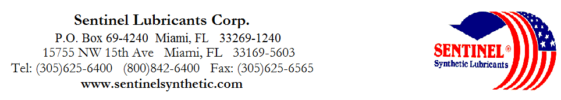

TYPICAL CHARACTERISTICS

SCO-S Series
SUPER SYNTHETIC
AIR COMPRESSOR OILS

SCO-10S SCO-10W20S SCO-20S SCO-30S SCO-40S ASTM METHOD

ISO Viscosity Grade 32 46 68 100 D-2422
SAE Viscosity Number 10 20 20 30 J-300
Viscosity cSt @ 100°C 5.4 10.6 8.6 12.4 17.9 D-445
@ 40°C 28.2 58 46.4 66.4 102 D-445
Viscosity Index 132 175 177 188 194 D-2270
Pour Point °C (°F) -57(-70) -48(-50) -54(-65) -51(-55) -45(-45) D-97
Flash Point °C (°F) 264(505) 266(510) 266(510) 266(510) 264(505) D-92
Fire Point ˚C (˚F) 280(535) 290(554) 280(550) 292(555) 288(550) D-92

Foam Sequence I, II, III -------------------------------------------------------- Nil ---------------------------------------------------------------- D-892
Demulsibility 54.4°C (130°F) ----------------------------------------------------- 40/40/0(15) ------------------------------------------------------------- D-1401
Four Ball Wear, mm 40kg, 1200 rpm, 75°C (1hr) ------------------------------------ 0.5 ----------------------------------------------------------------- D-2266

Copper Corrosion 121°C(250°F), 3 hrs ------------------------------------------------- 1a ----------------------------------------------------------------- D-130

Rust Test ------------------------------------------------------- Pass ----------------------------------------------------------------- D-665AB

Conradson Carbon Residue % -------------------------------------------------------- 0.08 ----------------------------------------------------------------- D-189
Autoignition Temperature °C (°F) ------------------------------------------------------ 410(765) ---------------------------------------------------------------- D-2155
Oxidation Test, hrs ------------------------------------------------------ 16000+ ---------------------------------------------------------------- D-943

USDA Rating -------------------------------------------------------- H-2 ------------------------------------------------------------------
PIN# 14120 14190 14130 14140 14150
TO ORDER or FOR ADDITIONAL INFORMATION

