PRODUCT DATA SHEET

G

PRODUCT DESCRIPTION

SCO Series
SYNTHETIC
AIR COMPRESSOR OIL

Sentinel’s Synthetic Air Compressor Oils (SCO Series) are specifically compounded to give long, trouble-free operation of air compressors and vacuum pumps. They are recommended for all reciprocating, rotary, centrifugal, lobe and screw type air compressors, either stationary or portable.

SCO Oil Series are recommended for all service conditions from intermittent light load to continuous heavy-duty applications where its superior performance becomes more apparent.

PRODUCT ADVANTAGES

SCO Oil Series are made from highly refined, chemically stable, Polyalphaolefin (PAO), high viscosity index base stock, with a compounding including fortified high temperature ashless oxidation inhibitors, preventing gumming, sludge, and resin formation in the valves and working parts of the compressor.

Different from automotive oils approved for compressors and vacuum pumps, these products will not emulsify with water. They will not foam, and they will not form hard varnishes.

SCO Oil Series will tremendously reduce maintenance in all air compressors, as well as fire hazards and explosion risks.

Extended drain intervals
Extended oil separator service intervals
Fewer air filter changes
Improved compressor efficiencies
Less downtime
Reduced feed rates
Reduced oil carryover
Reduced vapor pressure
Reduced equipment operational problems
Reduced oil consumption
Reduced maintenance costs
Improved Safety
Eliminates seasonal oil change
Excellent high temperature stability
Improved oxidation stability
Energy conservation
Less oil carryover
Cooler running
TO ORDER or FOR ADDITIONAL INFORMATION

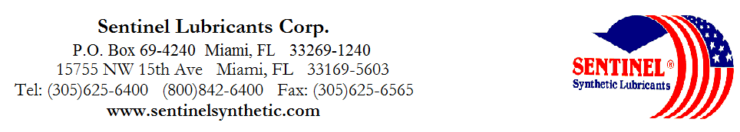

SCO Series
SYNTHETIC
AIR COMPRESSOR OIL

TYPICAL CHARACTERISTICS

SCO 10 SCO 10W 20 SCO 20 SCO 30 SCO 40 ASTM METHOD

ISO Viscosity Grade 32 46 68 100 150 D-2422
SAE Viscosity Number 10 20 20 30 40 SAE J-300
Viscosity cSt @ 100°C 5.9 7.3 10.6 14 17 D-445
@ 40°C 30.4 42.3 67.2 95 142
Viscosity Index 142 136 155 151 130 D-2270
Pour Point °C (°F) -43(-45) -40(-40) -40(-40) -37(-35) -35(-30) D-97
Flash Point °C (°F) 232(450) 243(470) 243(470) 260(500) 260(500) D-92

Foam Sequence I, II, III --------------------------------------------------------------------Nil---------------------------------------------------------------- D-892
Demulsibility 54.4°C (130°F) ---------------------------------------------------------------40/40/0(15)---------------------------------------------------------- D-1401
Four Ball Wear, mm 40kg, 1200 rpm, 75°C (1hr)-------------------------------------------------.5----------------------------------------------------------------- D-2266

Copper Corrosion 121°C(250°F), 3 hrs -------------------------------------------------------------1a----------------------------------------------------------------- D-130

Rust Test ------------------------------------------------------------------Pass--------------------------------------------------------------- D-665AB

Conradson Carbon Residue % -------------------------------------------------------------------.02---------------------------------------------------------------- D-189
Autoignition Temperature °C (°F)------------------------------------------------------------400(750)----------------------------------------------------------------- D-2155
Oxidation Test, hrs. -------------------------------------------------------------------8000+-------------------------------------------------------------- D-943

USDA Rating ---------------------------------------------------------------------H-2----------------------------------------------------------------
PIN# 14000 14085 14010 14020 14030
TO ORDER or FOR ADDITIONAL INFORMATION

