PRODUCT DATA SHEET

G


CITRA-SOLV
ALL NATURAL CLEANER
AND DEGREASER

PRODUCT DESCRIPTION

Sentinel’s Citra-Solv is a heavy duty cleaner and degreaser that will easily remove dirt, oil and grease from surfaces. Citra-Solv is all natural, biodegradable, water risible, and non-toxic.

TYPICAL CHARACTERISTICS

Citra-Solv is used to clean knives, saw blades, tools equipment, tables, painted surfaces, conveyers, hard surfaces, machinery, industrial equipment, materials handling equipment, and electric motors.

Specific Gravity, g/cc @ 60/60°F 0.85
Flash Point, °C (°F) 46 (115)
Boiling Point, °C (°F) 154 (310)
Acid Number, mg KOH/g 0.14
Kauri Butanol Value 62.7
Weight/ lbs/gal @ 21°C (70°F) 7.1
Refractive Index 1.4711
Odor Strong Citrus
Color Clear to Yellow Cast

PIN # 02320

TO ORDER or FOR ADDITIONAL INFORMATION

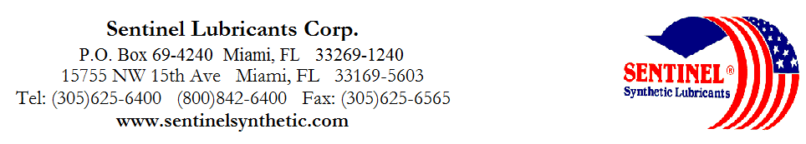

TECHNICAL DATA

CITRA-SOLV
ALL NATURAL CLEANER
AND DEGREASER

DIRECTIONS:

TO CLEAN & DEGREASE SURFACES: Dilute 4 oz. Into 1 gallon of warm water. Apply solution generously to surface to be cleaned. Let stand for 5 minutes. Rinse thoroughly.

FOR ODOR CONTROL: Dilute 2 oz. Into 1 gallon of cold water. Apply through a sprayer to odor source. Results in immediate fresh citrus scent.

TO UNCLOG DRAINS: Pour 8 oz. directly into drain. Let stand for 1 hour or more. Flush with hot water. For disposal, use same procedure.
USED TO:

Degrease Trucks Remove Decals
Unclog Grease Clean Drains
Remove Printer’s Ink Remove Adhesive
Remove Tire Marks Clean Motors
Remove Soap Scum Clean Equipment
De-tar Vehicles & Loosen Chewing Gum from Carpets & Hard Surfaces (other than plastic)
Cleans Fuel Oil Deposits from Metal Surfaces

100% Organic Formulation. 1 step degreasing and deodorizing. NON-CORROSIVE. Contains no Petroleum Distillates, Organic Halides or Alkalies – Will strip grease and heavy oil deposits from virtually any surface. Emulsifies instantly in water to penetrate and liquefy many different types of resins and greases.

CAUTION: KEEP OUT OF REACH OF CHILDREN

Combustible – Keep away from heat and open flame. Do not take internally. Avoid contact with eyes. In case of contact, immediately flush eyes with plenty of water for at least 15 minutes. If irritation persists, seek medical attention. If swallowed, consult a physician immediately. May be harmful to plastics or painted surfaces. TEST SURFACE IN AN INCONSPICUOUS AREA BEFORE USING. Because it is powerful grease solvent, it will defat skin. Use of rubber gloves are recommended to avoid chapped skin. Keep container tightly closed when not in use. For Commercial and Industrial Use only, or for sale to, use and storage by service persons.

USED IN:

Sewage Plants Schools
Service Stations Restaurants
Garbage Trucks Office Buildings
Automotive Plants Apartments
Theaters Nursing Homes
Locker Rooms Hospitals
Rest Rooms Commissaries

TECHNICAL DATA

CITRA-SOLV
ALL NATURAL CLEANER
AND DEGREASER

COMPATIBILITY CHART

CPVC No effect-Excellent
Epoxy No effect-Excellent
Polypropylene Moderate effect-Fair
Polyethylene Moderate effect-Fair
PVC Minor effect-Good
Cycolac (ABS) (Reg TM Borg-Warner Co.) Minor effect-Good
Phenolic No effect-excellent
Nylon No effect-excellent
Noryl (Reg TM General Electric Co.) UNKNOWN
Delrin (Acetal) (Reg TM E.I. du pont de Nemours & Co.) Severe effect-Not Recommended
Ryton to 200°F (Reg TM Phillips Petroleum Co.) UNKNOWN
Kynar (PVDF) (Reg TM Pennwalt Corp.) No effect-Excellent
Teflon (Reg TM E.I. Dupont de Nemours & Co.) No effect-Excellent
Stainless Steel (316) No effect-Excellent
Stainless Steel (304) No effect-Excellent
Stainless Steel (440) No effect-Excellent
Titanium No effect-Excellent
Carpenter 20 No effect-Excellent
Cast bronz No effect-Excellent
Aluminum No effect-Excellent
Hastelloy C No effect-Excellent
Carbon/ceramic No effect-Excellent
Ceramagnet A No effect-Excellent
Viton (Reg TM E.I. du pont de Nemours & Co.) No effect-Excellent
Burna N No effect-Excellent
Neoprene Moderate effect-Fair
Nitrile No effect-Excellent
Natural Rubber Moderate effect-Fair
Hypalon (Reg TM E.I. du pont de Nemours & Co.) UNKNOWN
EPDM UNKNOWN
Kel-F (Reg TM 3M Company) UNKNOWN
Tygon (Reg TM Norton Co.) Moderate effect-Fair
Silicone Severe effect-Not recommended
Ceramic No effect-Excellent
Carbon/graphite No effect-Excellent

Recommended Gasket Material: Man-holes use Viton®
Pump parts use Teflon®
O-Rings use Fluro-Silicon®
Rubber gaskets must be periodically replaced
TO ORDER or FOR ADDITIONAL INFORMATION

