PRODUCT DATA SHEET

G


S-FRH 46
FIRE RESISTANT
HYDRAULIC FLUID

PRODUCT DESCRIPTION

Sentinel® S-FRH 46 is a high molecular weight, polyol ester base, synthetic fire resistant biodegradable hydraulic fluid; which is recommended for those hydraulic applications where potential fire hazard exists. S-FRH 46 has high viscosity and viscosity index which make it useful in a wide range of industrial lubricant applications.

• Meets Mil H 83282 & all others

TYPICAL CHARACTERISTICS

S-FRH 46 base fluids contain a highly specialized additive system. This additive system provides S-FRH 46 exceptional anti-wear, rust and oxidation inhibiting, corrosion inhibiting and demulsibility properties.

S-FRH 46, like any other synthetic fluid, under the proper circumstances will burn. However, unlike some synthetic base fluids when burned, S-FRH 46 does not evolve large volumes of dense and noxious smoke and fumes.

ISO Viscosity Grade 46 ASTM D-2422
SAE Viscosity Number 20W SAE J-300
AGMA Lubricant Number
Viscosity cSt @ 100˚C 9.6 ASTM D- 445
@ 40˚C 47.5
Viscosity Index 192 ASTM D-2270
Pour Point ˚C (˚F) -4 (-20) ASTM D- 97
Flash Point ˚C (˚F) 314 (595) ASTM D- 92
Fire Point ˚C (˚F) 372 (700)
Foam Sequence I, II, III Pass ASTM D- 892
Demulsibility 82˚C 40-40-0 (15) ASTM D-1401
Copper Corrosion
121˚C (250˚F), 3 hrs. 1a ASTM D- 130
Rust Test Pass ASTM D- 665 A & B
USDA Rating H-2
Color Observed Clear
PIN # 10240
TO ORDER or FOR ADDITIONAL INFORMATION

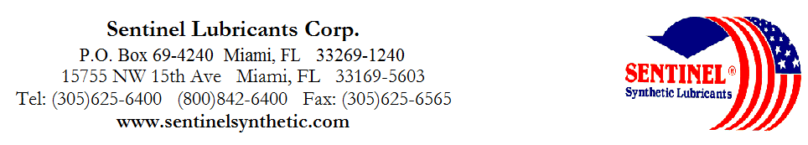

PRODUCT DATA SHEET (continued)

G

S-FRH 46
FIRE RESISTANT
HYDRAULIC FLUID

CONVERSION PROCEDURE

Converting from Other Polyol Ester Fluids,
Phosphates Esters or Oil-Synthetic Blends:

S-FRH 46 is compatible and miscible with polyol esters, phosphate esters, and oil-synthetic blends, as long as the used fluids are in good condition and contain no water. Simply add S-FRH 46 to the system, or to completely convert, drain the oil fluid and recharge with S-FRH 46. Flushing is not necessary.

To Convert from Water Containing Fluids:

Water containing fluids such as water glycols, invert emulsion and thickened high water content fluids must be thoroughly drained and the system flushed with S-FRH 46. For optimum performance, the operational S-FRH 46 should have a water content of less than 1%.

To Convert from Petroleum Oil-Based Fluids:

Completely drain and recharge the system with S-FRH 46. However, to preserve the highest degree of fire resistance, petroleum oil residual should be less than 5%. Depending upon the system design, this may require a flush with
S-FRH 46 following the drain. In all conversion, consideration should be given to the use of proper seals and hoses. This is also an appropriate time for the cleaning and/or replacement of suction strainers and filter elements to ensure trouble free operation after changeover.

S-FRH 46 is compatible with all ferrous and non-ferrous metals and their alloys. S-FRH 46 is also compatible with the following elastomers normally used with oil base hydraulic fluid.

Elastomers Compatibility
Fluroro-elastomer (Vitron, Teflon) Satisfactory
Nitrile Buna N Satisfactory
Polyurethane Satisfactory
Nylon Satisfactory
Silicon Rubber Satisfactory
Butyl Satisfactory but with reduced life
Ethylene Propylene Satisfactory but with reduced life
EP R Satisfactory but with reduced life
Neoprene Satisfactory but with reduced life
Low Nitrile Buna N Satisfactory but with reduced life
TO ORDER or FOR ADDITIONAL INFORMATION

