PRODUCT DATA SHEET



S-MPO OIL Series
MULTI-PURPOSE OIL

PRODUCT DESCRIPTION

Sentinel S-MPO Multi-Purpose oil is a specially compounded synthetic oil to meet the needs of all types of industrial lubrication.

S-MPO Multi-Purpose oil offers a superior combination of oxidation inhibitors to prevent sludging and deposit formation; a high level of E.P. additives to meet severe wear protection requirements; foam suppressants to eliminate foaming; and finally a new polymer additive to arrest leakage and assure a strong bond to metal retention for maximum “grip” to all surfaces. It will not drip-out, fling-out or run-out.

S-MPO gives superior protection against corrosion, rubber swelling and exhibits excellent water demulsibility characteristics. These are the qualities that are required to assure efficient, trouble-free operation and extended drain intervals of the new high modern equipment of today.
TO ORDER or FOR ADDITIONAL INFORMATION

S-MPO Multi-Purpose oil has proved itself in applications such as:

- Bearings
- Gears
- Electric Motors
- Hydraulic Systems
- Low Speed Spindles
- Machine Tool ways
- Small Precision Gearing
- And many types of Chain Conveyors (Not be used as crankcase or air compressor lubricant)

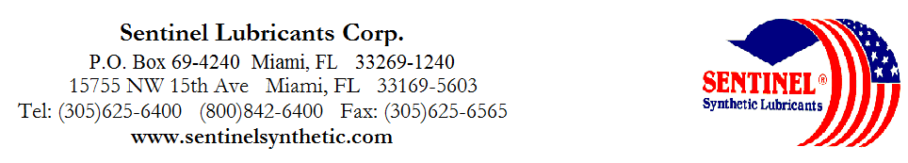

S-MPO OIL Series
MULTI-PURPOSE OIL

TYPICAL CHARACTERISTICS

10 20 30 10/50 40 50

ISO Viscosity Grade 32 68 100 100 150 220 ASTM D- 2422

AGMA Lubricant Number 1 2 3 3 4

Viscosity cSt @ 100°C 5.6 9 12 18 16.3 21.3 ASTM D- 445
@ 40°C 32 68 100 100 150 220 ASTM D - 445
Viscosity Index 114 107 110 180+ 111 113 ASTM D- 2270

Pour Point °C (°F) -40(-40) -37(-35) -34(-30) -37(-35) -32(-25) -29(-20) ASTM D- 97

Flash Point °C (°F) 200(392) 210(410) 220(428) 230(446) 224(435) 230(446) ASTM D- 92

Demulsibility 82°C --------------------------------------------40/40/0(30) -------------------------------------- ASTM D- 1401

Four Ball Wear, mm
40 kg, 1200 75˚C (1 hr) -----------------------------------------------.5m--------------------------------------------- ASTM D- 2266

C Copper Corrosion 121°C(250°F), 3 hrs --------------------------------------------1a------------------------------------- ASTM D- 130

Rust Test ------------------------------------------------Pass------------------------------------------- ASTM D-665A&B

Timken OK Load kg/ (lb.) ------------------------------------------------25 (55) ---------------------------------------- ASTM D- 2509

Conradson Carbon ------------------------------------------------0.05-------------------------------------------- ASTM D- 189
Appearance ----------------------------------------------Light Green-------------------------------------
PIN # 08045 08050 08055 08076 08060 08065
TO ORDER or FOR ADDITIONAL INFORMATION

