PRODUCT DATA SHEET

G


S-GEAR OIL Series
GEAR OIL SERIES

PRODUCT DESCRIPTION

Sentinel® Special Synthetic Gear Oils are multi-purpose specially compounded molybdenum sulfide gear lubricants formulated to provide superior film strength and extreme pressure properties. They are truly anti-friction, anti-wear, anti-leak, anti-foam gear oils. Sentinel® Special Synthetic Gear Oils also surpass FZG stage 12, the highest rating that can be attained. They can be used as make-up and refill lubricants in all types of enclosed gear mechanisms, including spur, herringbone, spiral, bevel and hypoid. Sentinel® Gear Oil Series will also adequately meet and surpass requirements of heavy duty industrial transmissions and gear trains subject to high load and impact loads.

PRODUCT ADVANTAGES

Sentinel® Special Synthetic Gear oils are formulated to greatly improve the viscosity temperature slope. In other words, they reduce the change in viscosity with increase in temperature under isothermal conditions. The non-Newtonian behavior of these lubricants have shown greater reduction in friction and wear due to maintaining greater film thickness on gear teeth, thereby reducing amperage consumption, as well as reducing frictional heat.

When severe rise in temperature is reached, these lubricants will carry greater loads because of the flatter viscosity temperature slope. The non-Newtonian as well as the non-foaming properties of these lubricants practically eliminate all leakage.

- Extended drain intervals
- Superior demulsibility
- Non-foaming
- Seal compatible
- Less downtime
- Reduced equipment operational problems
- Reduced maintenance costs
- Improved Safety
- Improved oil leakage
- Eliminates seasonal oil change
- Exceptional high temperature stability
- Improved Oxidation Stability
- Energy Conservation
- Cooler running
TO ORDER or FOR ADDITIONAL INFORMATION

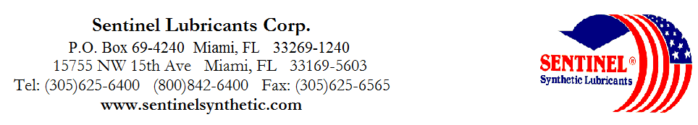

S-GEAR

OIL Series
GEAR OIL SERIES

TYPICAL CHARACTERISTICS

S-75 S-80 S-75/80 S-75/90 S-80/90 S-90 S-90/140 S-140 S-250 ASTM METHOD

ISO Viscosity Grade 32 46 68 100 150 220 320 460 680 D- 2422

AGMA Lubricant Number 1EP 2EP 3EP 4EP 5EP 6EP 7EP 8EP

Viscosity cSt @ 100°C 6 8 10 14 18 23 29 37 48 D- 445
@ 40°C 32 46 68 100 150 220 320 460 680 D- 445
Viscosity Index 133 146 131 142 124 124 124 124 124 D- 2270

Pour Point °C (°F) -48(-55) -46(-50) -43(-45) -40(-40) -37(-35) -34(-30) -32(-25) -29(-20) -26(-15) D- 97

Flash Point °C (°F) 231(448) 233(451) 236(457) 249(480) 250(482) 254(490) 270(518) 280(535) 280(535) D- 92

Foam Sequence I, II, III --------------------------------------------------------------------Pass----------------------------------------------------------------- D- 892
Demulsibility 82°C ---------------------------------------------------------------40/40/0(30)-------------------------------------------------------------- D- 1401
Four Ball Wear, mm 40kg, 1200 rpm, 75°C (1hr)-------------------------------------------------.34------------------------------------------------------------------- D- 2266

Copper Corrosion 121°C(250°F), 3 hrs -------------------------------------------------------------1a------------------------------------------------------------------- D- 130

Rust Test ------------------------------------------------------------------Pass----------------------------------------------------------------- D-665A&B

Gear Test, FZG, SPUR, Stage Pass -----------------------------------------------------------------12+------------------------------------------------------------------

Timken OK Load kg/(lb) ----------------------------------------------------------------45+(100)----------------------------------------------------------------- D- 2509

USDA Rating ---------------------------------------------------------------------H-2------------------------------------------------------------------
Appearance ---------------------------------------------------------------Dark Grey ----------------------------------------------------------------
PIN 07049 07110 07050 07070 07130 07170 07190 07210 07230
TO ORDER or FOR ADDITIONAL INFORMATION

