PRODUCT DATA SHEET

G

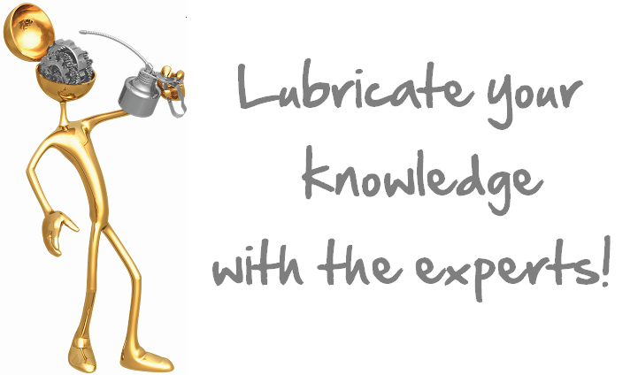

SLC C-4 FLUID
TRANSMISSION
FINAL DRIVE/HYDRAULIC

PRODUCT DESCRIPTION

Sentinel® SLC C-4 Fluid is a blended synthetic high performance drive train fluid especially formulated for use in transmissions, differential, final drive gear, and hydraulic system requiring a fluid meeting Allison C-4/C-3/C-2 or Caterpillars TO-4/TO-2 requirements.

Sentinel® SLC C-4 Fluid is recommended for the automatic transmission of heavy duty truck and tractor, off highway, construction, earth moving machines and mobile hydraulic systems where operating requirements are severe.

Sentinel® SLC C-4 Fluid is a universal lubricant. It can be used as the wet brake and power take off fluid and as power steering fluid.

TYPICAL CHARACTERISTICS

Sentinel® SLC C-4 Fluid has high oxidation resistance and low pour point. It has extreme pressure additive that provide excellent load carrying capacity and wear protection. In addition, it is rust and foam inhibited, resists water, and is compatible with commonly used seal materials. Also, it has a high viscosity index to help insure good high and low temperature performance.

Product Advantages
Long Life Fluid
Non-Corrosive
High Oxidation Stability
Minimize Varnish and Sludge Formation
Excellent Seal Compatibility
Maintains Excellent Low Temperature Flow Properties
Excellent Frictional Control

ISO Viscosity Grade 68 ASTM D-2422

SAE Viscosity Grade 20W

Viscosity cSt @ 100°C 9.4 ASTM D- 445
@ 40°C 58.3

Viscosity Index 145 ASTM D-2270

Pour Point ˚C (˚F) -40 (-40) ASTM D- 97

Flash Point ˚C (˚F) 225 (437) ASTM D- 92

Foam Sequence I, II, III Pass ASTM D- 892

Demulsibility, 82˚C 40/40/0 (15) ASTM D- 1401

Rust Test Pass ASTM D-665A&B

PIN # 18552
TO ORDER or FOR ADDITIONAL INFORMATION

