PRODUCT DATA SHEET

G


S-SYNVAC Series
SYNTHETIC
VACUUM PUMP FLUID

PRODUCT DESCRIPTION

S-SYNVAC Series are super synthetic Vacuum Pump Fluids designed to give excellent service and long fluid life in all types of vacuum pumps. These fluids have very low vapor pressure and very high oxidation resistance. They also have excellent thermal and shear stability

PROPERTIES

S-SYNVAC Series lubricants protect against wear, rust, corrosion and they work on rotary screw, sliding vane, reciprocating and liquid ring vacuum pumps, keeping them free from varnish, carbon, and sludge deposits.

      - Outstanding thermal and oxidation stability and very long fluid life
      - Very high viscosity index for better compressor protection
      - Very low vapor pressure /volatility
      - Excellent coolant properties
      - Extremely high film strength and anti wear properties
      - Very long life fluid allows for extend oil drains
      - Excellent carbon and varnish control to help reduce deposits
      - Excellent rust & corrosion control

TO ORDER or FOR ADDITIONAL INFORMATION

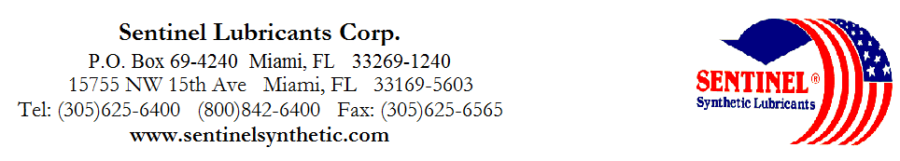

S-SYNVAC Series
SYNTHETIC
VACUUM PUMP FLUID

TYPICAL CHARACTERISTICS

S-SYNVAC-15 S-SYNVAC-22 S-SYNVAC-32 S-SYNVAC-46 ASTM METHOD

ISO Grade 15 22 32 46 D-2442
Viscosity Index 129 125 123 130 D-2270
Viscosity cSt @ 40°C 14.8 20.1 33.1 47.2 D-445
@100°C 3.6 4.3 5.9 7.7
Pour Point °F -55 -53 -50 -45 D-97

Flash Point °F 386 398 430 440 D-92
Four Ball Wear, mm 40kg, 1200 rpm ------------------------------------------------ 0.5 ----------------------------------------------
167°F 1Hr,Scar Dia mm ------------------------------------------------ 0.40 ---------------------------------------------- D-2266

Copper Corrosion 24Hr ----------------------------------------------- 1a ---------------------------------------------- D-130

Rust Test ----------------------------------------------- Pass ---------------------------------------------- D-665 A+B

Demulsibility, 130°F, 30min ---------------------------------------------- 40/40/0 ---------------------------------------------- D-1401
Vapor Pressure mm Hg @ 80°F ---------------------------------------------- 0.00005 ----------------------------------------------
Specific Gravity, at 60ºF 0.817-0.820 0.821-0.824 0.825-0.829 0.830-0.834
Molecular Weight GPC, # AVG 443 501 554 629
Pin # : 14915 14922 14932 14948
TO ORDER or FOR ADDITIONAL INFORMATION

S-SYNVAC Series
SYNTHETIC
VACUUM PUMP FLUID

TYPICAL CHARACTERISTICS

S-SYNVAC-68 S-SYNVAC-100 S-SYNVAC-150 S-SYNVAC-220 ASTM METHOD

ISO Grade 68 100 150 220 D-2442
Viscosity Index 130 133 128 143 D-2270
Viscosity cSt @ 40°C 68.3 105 150 220 D-445
@100°C 10.0 13.9 17.5 25
Pour Point °F -43 -40 -40 -40 D-97

Flash Point °F 460 514 525 530 D-92
Four Ball Wear, mm 40kg, 1200 rpm ------------------------------------------- 0.5 -------------------------------------------------- D-2266
167°F 1Hr,Scar Dia mm ------------------------------------------- 0.40 -------------------------------------------------- D-2266

Copper Corrosion 24Hr ------------------------------------------- 1a -------------------------------------------------- D-130

Rust Test ------------------------------------------- Pass -------------------------------------------------- D-665 A+B

Demulsibility, 130°F, 30min ------------------------------------------- 40/40/0 -------------------------------------------------- D-1401
Vapor Pressure mm Hg @ 80°F ------------------------------------------- 0.00005 ------------------------------------------------- D-2266
Specific Gravity, at 68ºF 0.834-0.838 (60ºF) 0.839-0.843 0.844 - 0.848 0.849 - 0.853
Molecular Weight GPC, # AVG 690 751
Pin # : 14968 14989 14995 14998
TO ORDER or FOR ADDITIONAL INFORMATION

