PRODUCT DATA SHEET

G



SPINDLE

OIL Series

PRODUCT DESCRIPTION

Sentinel’s non-newtonian spindle oils have been scientifically blended with EP and rust and oxidation additives to reduce friction and wear, thereby reducing amperage as well as frictional heat. These fluids are non-staining, non-corrosive with virtually no odor, specifically developed for the knitting industries as a lint-free oil.

PRODUCT ADVANTAGES

Sentinel’s special spindle oils will be pulled into the spindle bearing and gears, they will penetrate and lubricate pins in chains and will not drip off or be absorbed as quickly as conventional oils. These fluids will extend lubrication intervals and provide superior lubrication through normal cycles. As a lubricant the long chain molecules will reduce wear and increase tool life up 50% by wrapping around the spindle bearing and clutches to provide bounding film lubrication.

Extend Lubrication Cycle
Non-Foaming
Non-Staining
Reduced Maintenance Cost
Improved Efficiencies
Improved Safety
Improved Oxidation Stability
Cooler Running
TO ORDER or FOR ADDITIONAL INFORMATION

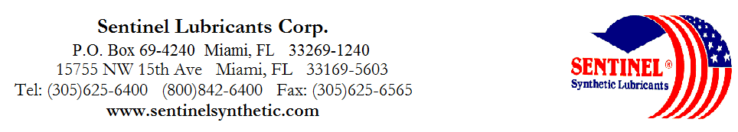

SPINDLE

OIL Series

TYPICAL CHARACTERISTICS

L LM M M-M H ASTM METHOD

ISO Viscosity Grade 2 10 22 32 46 D- 2422

Viscosity cSt @ 100°C 1.5 2.1 3.9 5.7 7.7 D- 445
@ 40°C 5.5 7.19 17 31 46 D- 445

Pour Point °C (°F) -73(-100) -63(-80) -51(-60) -48(-55) -43(-45) D- 97

Flash Point °C (°F) 155(311) 160(320) 169(336) 180(356) 190(374) D- 92

Foam Sequence I, II, III -----------------------------------------------------Pass------------------------------------------------- D- 892
Demulsibility, 54°C (130˚F) -------------------------------------------------40/40/0(30)-------------------------------------------- D- 1401

Copper Corrosion 121°C (250°F), 3 hrs ----------------------------------------------------1a---------------------------------------------------- D- 130

Rust Test ----------------------------------------------------Pass-------------------------------------------------- D-665A&B

Conradson Carbon ----------------------------------------------------0.01-------------------------------------------------- D- 189
Appearance ------------------------------------------------Yellow Cast--------------------------------------------- D- 1500

PIN# 11500 11503 11505 11507 11510

TO ORDER or FOR ADDITIONAL INFORMATION

SPINDLE

OIL Series

TYPICAL CHARACTERISTICS

L LM M M-M H ASTM METHOD

Specific Gravity, g/ml @ 25°C 0.7976 0.807 0.814 0.821 0.827 D- 1298

Viscosity Index 80 85 125 120 135 D- 2270

Density, lb/gal @ 25°C 6.59 6.69 6.78 6.84 6.89 D- 1298

TAN, mg/KOH/g ---------------------------------------------- 0.10 ------------------------------------------- D- 974

Evaporating Loss, 22hrs @ 40°C ------------------------------------------- 0.10 ------------------------------------------- D- 972
Operating Temperatures -57°C(-70°F) -54°C(-60°F) -40°C(-40°F) -40°C(-40°F) -35°C(-30°F)
Intermittent to to to to to
60°C(140°F) 65°C(149°F) 70°C(150°F) 86°C(176°F) 86°C(185°F)

Surface Tension @ 100°C dynes/cm --------------------------------------- 23 --------------------------------------------

------- No Ash Content ------- No Saponification Value ------ No Fats in our Oils -------

PIN# 11500 11503 11505 11507 11510
TO ORDER or FOR ADDITIONAL INFORMATION

